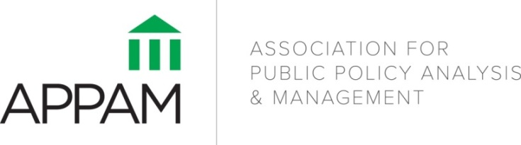

Social Experiments in Practice: The Why, When, Where, and How of Experimental Design and Analysis
APPAM-Abt Institutional Member Forum
April 24, 2014

Related Reading

This list of citations includes recommendations from the Forum speakers as relevant to the discussion of Social Experiments in Practice. While it is not an exhaustive list of articles, it is intended to provide additional background and detail to the presentations that are part of the Forum.

Bell, Stephen H. & Laura R. Peck. (2013). Using Symmetric Predication of Endogenous Subgroups for Causal Inferences about Program Effects under Robust Assumptions: Part Two of a Method Note in Three Parts. American Journal of Evaluation, 34(3): 413-426. DOI: 10.1177/1098214013489338

Cole, Stephen R. & Elizabeth A. Stuart. (2010). Generalizing Evidence from Randomized Clinical Trials to Target Populations: the ACTG-320 Trial. American Journal of Epidemiology, 172(1): 107-115. PMCID: PMC2915476. Available at: http://www.ncbi.nlm.nih.gov/pubmed/20547574

Epstein, Diana & Jacob A.Klerman. (2012). When is a Program Ready for Rigorous Impact Evaluation? The Role of A Falsifiable Logic Model. Evaluation Review, 36(5): 375-401. DOI: 10.1177/0193841X12474275

Harvill, Eleanor L., Laura R. Peck & Stephen H. Bell. (2013). On Overfitting in Analysis of Symmetrically Predicted Endogenous Subgroups from Randomized Experimental Samples: Part Three of a Method Note in Three Parts. American Journal of Evaluation, 34(4): 545-556. DOI: 10.1177/1098214013503201

Imai, Kosuke, Gary King, & Elizabeth A. Stuart. (2008). Misunderstandings Between Experimentalists and Observationalists about Causal Inference. Journal of the Royal Statistical Society, Series A, 171(2): 481-502. Available at http://onlinelibrary.wiley.com/doi/10.1111/j.1467-985X.2007.00527.x/full

Mead, Lawrence M. (2012). Implementing Work Programs for Poor Men. Policy Studies Journal, 40(4): 575-600.

Mead, Lawrence M. (1997). Optimizing JOBS: Evaluation Versus Administration. Public Administration Review, 57(2): 113-23.

Mead, Lawrence M. (2003). Performance Analysis, in Policy into Action: Implementation Research and Welfare Reform, chapter 6, eds. Mary Clare Lennon & Thomas Corbett. Washington, DC: Urban Institute Press.

Mead, Lawrence M. (2005). Policy Research: The Field Dimension. Policy Studies Journal, 33(4): 535-57.

Olsen, Robert, Stephen H. Bell, Larry Orr, & Elizabeth A. Stuart. (2013). External Validity in Policy Evaluations that Choose Sites Purposively. Journal of Policy Analysis and Management 32(1): 107-121. NIHMS 382967. Available at: http://onlinelibrary.wiley.com/doi/10.1002/pam.21660/full

Peck, Laura R. (2013). On Analysis of Symmetrically-Predicted Endogenous Subgroups: Part One of a Method Note in Three Parts. American Journal of Evaluation, 34(2): 225-236. DOI: 10.1177/1098214013481666

Peck, Laura R. (2007). What are the Effects of Welfare Sanction Policies? Or, Using Propensity Scores as a Subgroup Indicator to Learn More from Social Experiments. American Journal of Evaluation, 28(3), 256-274. DOI: 10.1177/1098214007304129

Peck, Laura R. (2005). Using Cluster Analysis in Program Evaluation. Evaluation Review, 29(2), 178-196. DOI: 10.1177/01933841X04266335

Peck, Laura R. (2003). Subgroup Analysis in Social Experiments: Measuring Program Impacts Based on Post-Treatment Choice. American Journal of Evaluation, 24(2), 157-187. DOI: 10.1016/S1098-2140(03)00031-6

Stuart, Elizabeth A., Stephen R. Cole, Catherine P. Bradshaw, & Philip J. Leaf. (2011). The Use of Propensity Scores to Assess the Generalizability of Results from Randomized Trials. The Journal of the Royal Statistical Society, Series A, 174(2): 369-386. PMID: 22806931. Available at: http://www.ncbi.nlm.nih.gov/pubmed/22806931

